Author’s Guide to Preparing Papers for Proceedings of the 16th Multidisciplinary Conference on Sinkholes and the Engineering and Environmental Impacts of Karst

Format
Papers must be submitted electronically via the Sinkhole Conference website using the provided Manuscript Template (MS Word) to ensure correct formatting, fonts, and layout. The correct fonts, sizes, margins, etc., are already built into the template; please do not change them. We suggest the maximum length of each manuscript be limited to ten formatted pages, including all figures, text, and references. Contact Lewis Land (lland@nckri.org) for questions about formatting.

Units and Terms
We ask that authors always employ the metric system when citing units in the text. English units may be inserted parenthetically at the author’s discretion (the editors are aware of the irony of requiring metric units in the manuscript, and then specifying formatting margins, page size, and figure sizes in inches, but this convention simplifies production of the final Proceedings document).

In accordance with new USGS guidelines, please use the term “groundwater,” as opposed to “ground water” or “ground-water.” For a glossary of terms related to karst, please see A Lexicon of Cave and Karst Terminology with Special Reference to Environmental Karst Hydrology (Field, 2002).

Artwork
All figures must be uploaded as individual separate files via the “Supplemental Content” link on the Sinkhole Conference website at the time of submission of your formatted manuscript. Photographs and figures should also be included as flat files inserted into the MS Word manuscript at the sizes and in the locations you desire for formatting purposes. Should you need assistance with inserting a figure that will span the full width of the page in MS Word (rather than the width of a single column), please contact the editor and instructions will be provided to you.

Please do not create or add shapes, artwork, or annotations to figures using the tools within MS Word; these do not convert properly to PDF format. Rather, please add the shape or annotation to your figure within a program such as Paint, PowerPoint, Illustrator, or Photoshop, and then save the image as a flat image file, JPEG or TIF format. The editors will use the separate files to replace those in the MS Word file to preserve maximum quality of the images. Although we will attempt to adhere to the author’s preferred layout as much as possible, this cannot be guaranteed due to vagaries involved with compilation of all manuscripts into the final Proceedings document.

Please use the last name of the first author and the figure number as part of the file name of each digital image, for example: ‘Jones-fig.17.jpg’. Digital photos should be submitted in JPEG format, and graphic artwork as TIF files, with a minimum resolution of 300 dpi (dots per inch). Figures at 300 dpi resolution should be at least 3” x 4” (900 x1200 pixels). Line art will require at least double resolution. Color graphics are acceptable.

References
A list of references cited should be included at the end of the paper. Use 0.3 inch hanging indent for citations. Examples of the acceptable Council of Science Editors (CSE) citation style are provided below. Personal communications should not be included in the list of references but cited in the body of the text. For example, (Agassiz, 2003, personal communication) or (Von Humboldt, 2011, written communication). References to websites should include the full URL of the web address, as well as the date the site was last accessed. For multiple works by the same author or set of authors in the same year, assign letters chronologically, so that the work that was published first is listed, for example, as 2002a. For works with ten or more authors, list the first ten authors followed by “et al.”

Please adhere to the citation formats listed below:

Journal article, one author:
Klimchouk AB. 1997. The role of karst in the genesis of sulfur deposits, Pre-Carpathian region, Ukraine. Environmental Geology 31 (1): 1-20.

Journal article, two authors:
DuChene HR, Martinez R. 2000. Post-speleogenetic erosion and its effect on cave development in the Guadalupe Mountains, New Mexico and west Texas. Journal of Cave and Karst Studies 62 (2): 25-29.

Journal article, multiple authors:
Sherlock RL, Lee JKW, Cousens BL. 2004. Geologic and geochronologic constraints on the timing of mineralization at the Nanisivik Mississippi Valley-type deposit, northern Baffin Island, Nunavut, Canada. Economic Geology 99: 279-293.

Magazine article:
Cochran WW, Mouritsen H, Wikelski M. 2004 April 16. Migrating songbirds recalibrate their magnetic compass daily from twilight clues. Science 304: 127-133.

Books, one author:
White W. 1988. Geomorphology and hydrology of karst terrains. New York (NY): Oxford University Press. 508 p.

Books, specified edition, multiple authors:
Roberts C, Varty B, Lucas V. 2004. Writing for the biological sciences. 10th ed. Toronto (ON): Addison-Wesley. p. 73-76.

Editor of a book:
Simpson B, Callahan N, editors. 1989. Country singing aint for me. 3rd ed. Washington (DC): Country Press. 123 p.

Chapter or article in an edited book:
Evans S, Smith JA. 2000. Ecotourism in tropical rainforests: an environmental management option for threatened resources? In: Ford JT, Tribe R, editors. Forest tourism and recreation: case studies in environmental management. 4th ed. Wallingford (GB): CABI Publishing. p. 127-142.

Chapter or part of an authored book:
Shakelford RT. 1978. Surgery of the alimentary tract. Philadelphia (PA): WB Saunders. Chapter 2, Esophagoscopy. p. 29-40.

Conference proceedings:
Johnson PS, Land L, Price LG, Titus, F, editors. 2003. Water resources of the lower Pecos region, New Mexico: Science, policy, and a look to the future. Proceedings of the third New Mexico Bureau of Geology and Mineral Resources Decision Makers Conference; Albuquerque, New Mexico: University of New Mexico Press. 137 p.

Conference papers:
Van Houten N, Flanders R. 1975. Nachos Flanders style. In: Simpson C, Lumpkin L, editors. The Book of Nacho. Proceedings of the Fourth International Symposium on Stadium Food; 1976 Feb. 10-15; Vancouver, British Columbia. Pullman (WA): Fallout Press. p. 175-200.

Thesis or dissertation:
Simpson L. 2008. Level 5 Veganism: Consumption of nothing that casts a shadow [master's thesis]. Springfield (OR): Springfield University. 248 p.

Oliver SS. 2012. Context dependent protein interpretation of the histone language [dissertation]. Madison (WI): University of Wisconsin-Madison. 238 p.

Circulars and government reports:
Motts WS, Cushman, RL. 1964. An appraisal of the possibilities of artificial recharge to groundwater supplies in part of the Roswell Basin, New Mexico. US Geological Survey Water-Supply Paper 1785. 78 p.

Reference book entry:
Moore D. 2002. Fungal control of pests. In: Pimental D, editor. Encyclopedia of pest management. New York (NY): Marcel Dekker. p. 320-324.

Map
Barnes VE. 1975. Geologic atlas of Texas: Van Horn-El Paso sheet. 1:250,000. Austin (TX): Texas Bureau of Economic Geology.

Web page:
Scientists close in on source of X-rays in lightning [Internet]. 2008. [Place of publication unknown]: Scienceblog.com; [updated 2008 July 16; cited 2008 July 29]. Available from: http://www.scienceblog.com/cms/scientists-close-source-x-rays-lightning-16904.html.

Web page with personal author:
Troyer G. Sensory phantoms: dealing with the loss of a limb [Internet]. 2009. [Place of publication unknown]: Canadian Broadcasting Corporation; [updated 2009 Jan 5; cited 2009 Jan 13]. Available from: http://www.cbc.ca/health/story/2009/01/05/f-troyer-phantompain.html.

Article in an internet-only journal:
Sarkar T, Zhao W, Sarkar NH. 1995. Expression of junoncogene in rodent and human breast tumors. Journal of Biology [Internet]. [cited 2004 Dec 22]; 1(1): [about 8 screens]. Available from: http://epress.com/w3bio/vol1/sarkar/sarkar.html.

Technical report from research institution or government web site:
World health report 2004: Changing history [Internet]. 2004. Geneva (CH): World Health Organization [WHO]; [cited 2008 Jul 22]. 170 p. Available from: http://www.who.int/entity/whr/2004/en/report04_en.pdf

The manuscript submission procedure

Once logged in, upload your paper by clicking on the ‘Revise paper’ link in the upper left corner of the page that shows your abstract:
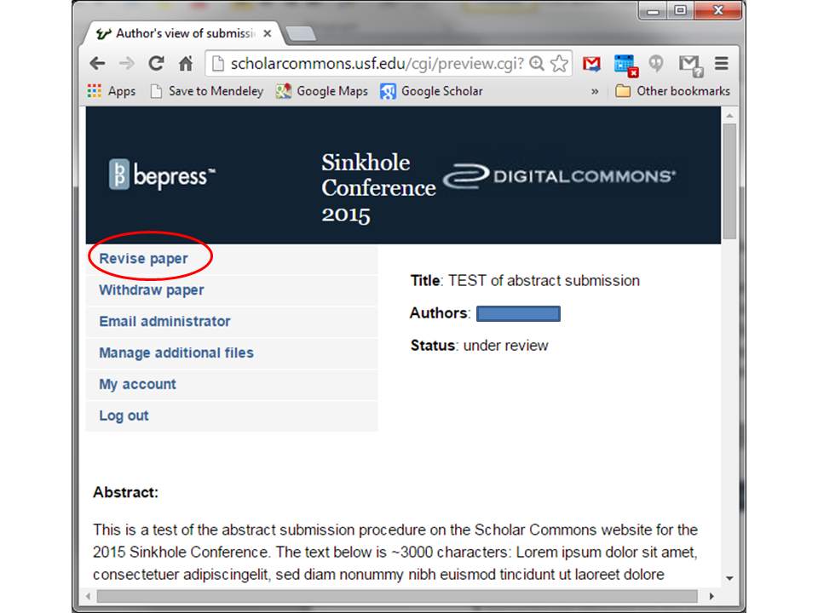

Make any changes you wish to the Abstract text, then scroll down to ‘Full Text of Presentation’ to upload your manuscript. Please indicate if you prefer an ORAL or POSTER presentation within the 'Reason for Update' box:
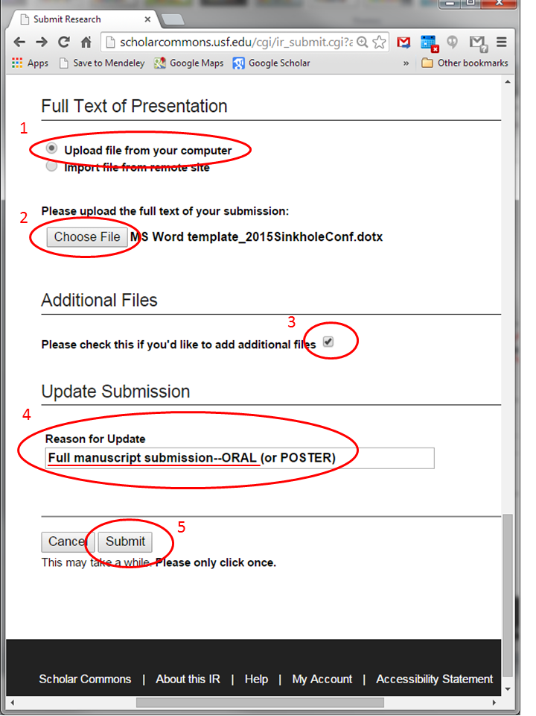

Upload all figures and tables individually as ‘Supplemental Content’ on the next page:

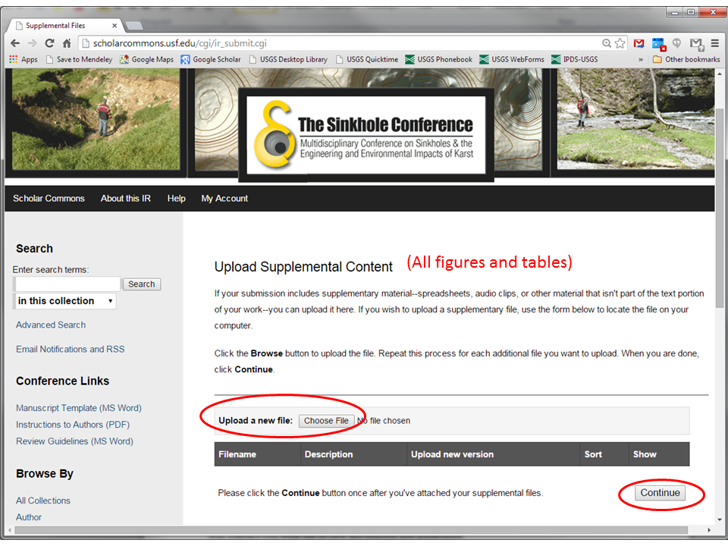

The deadline for receipt of first complete drafts of full papers for review is 14 October 2019. You may revise any files within your submission up until that date. When preparing your manuscript, you may include revisions to your abstract, which does not have to be identical to the one submitted. Emphasis of the abstract should be a concise description of your research that includes a brief but specific summary of your results.

